C# - Concepts
- Install
  - .net 10 SDK
  - VS Code
    - Plugin
      - C# dev kit
- Architecture
Console app (.csproj) → (.dll/.exe) → O/P
Class library (.csproj) → .dll → O/P
- UpperCamelCase - MyFirstSolution
lowerCameCase - myFirstSolution
- Structure of a C# project
Solution (.sln)
Project (.csproj)
.cs
- Datatypes
  - Pre-defined datatypes
  - Non-predefined datatypes
    - String
    - Array
    - User-defined datatypes
- Access modified
  - Private - accessible within the class
  - Internal - accessible within the assembly (.dll)
  - Protected - accessible in the child class
  - Protected internal
  - Public - accessible anywhere
- Class - A class is a template or blueprint or type from which objects are created.
- Object
  - An object is an instance of a class
  - Every object has its own state(non-static variable) and behaviour (non-static method)
- Encapsulation
- Constructor
  - Constructor name and classname should be the same
  - It is a method that gets called whenever an object is created
  - Always, the default constructor will be there,
  - We can override it by explicitly creating a constructor. But you have to call the constructor created during the object creation
    - Without arguments
    - With arguments
- this →
  - points to the current object
  - Helps to distinguish between an instance variable and a local variable
- base keyword
- Static polymorphism/method overloading/compile-time polymorphism
A method to be called is resolved during compile time.
Multiple methods with the same name due to a change in
  - Number of arguments
  - Datatypes of arguments
  - Sequence of arguments
- Constructor overloading
- Method overriding/ Runtime polymorphism
  - Create an object for the child and store it in the parent
- Abstraction - a pillar that hides internal implementation details and exposes only the essential features of an object.
  - Abstract class
  - Interface - An interface is a completely abstract class, which can only contain abstract methods and properties (with empty bodies)
- Collections
  - Non-generic vs Generic - List, Dictionary, Queue (FIFO), Stack (FILO)
  - Generic type
    - List<String>
    - Dictionary<T Key, T value>
    - Hashset → duplicates won’t be there
- Linq
  - Query method
  - Lamda method
- Delegates - help to pass a method as a parameter. (The method can be created and passed, or you can use a lambda function)
- Working on custom delegates
- Understanding func and actions delegates

asp.net core
- Understanding the architecture of ASP.NET Core (high-level)
- Working on terminal middleware to understand the HttpContext object, the flow of the application, the Kestrel server, and path handling.
- Working with HTTP requests.
- Project → ASP.NET Core Empty Project
- app.Run() → working on web api using terminal middleware
- app.MapGet, Post, Delete, Patch, Put
- Group the api services (app.MapGroup)
- Middleware (app.Use)
Middleware 1 → middleware 2 → middleware 3 → end point → middleware 3 → middleware 2 → middleware 1

- app.UseWhen()
If a delete request,
Middleware 1 → middleware 2 → middleware delete before (when delete-app.UseWhen) middleware 3 → endpoint → middleware 3 → middleware delete after (when delete-app.UseWhen) → middleware 2 → middleware 1
- app.Map()
- app.Mapwhen()
- Custommiddleware
- custom middleware (create a class implement IMiddleWare and register under a transient service, and call it
- CustomException Middleware
- MVC project
  - MVC → only with controller
  - MVC → controller-view (Home controller - View\home\index.cshtml)
  - MVC→ Controller-model-view
- Working on razor engine - understanding view
- BookManagement Portal
- Controller - Model - view → browser
- Validation
- Builtin middleware
//Adds the routing middleware to match incoming URLs to endpoints.
app.UseRouting();
app.UseHttpsRedirection();
app.UseStaticFiles(); → for bootstrap local binding
- Validation
- Custom Validation
- RazorPage Project (Understanding its life cycle, flow, validation, and form handling)
- Entity framework
  - Add dependency
  - Add model. AppDbContext, register the AddDBContext
- Entity Framework with migration
- Security Cookies → Razor page
  - Set up the [Authorize] or all folder under authorize in program.cs
  - Cookies implementation
- Security - JWT
  - Install nuget → Microsoft.AspNetCore.Authentication.JwtBearer
  - Set up JWT Authentication and authorization service
  - Call the Authentication and authorization middleware
  - Create a post request to get token
  - Use the token for further HTTP requests.
- Loggers →
  - Default logger
  - Serilog - file creations and logs
- IIS hosting -

- Azure
az login
az webapp up --name <your-app-name> --resource-group <your-resource-group> --runtime <runtime-stack>
Zip deployment :
az webapp deploy --name <your-app-name> --resource-group <your-resource-group> --src-path <path-to-zip-file>

- Some are updated in PPT

Copilot features:
- Ask, agent, plan
- Custom instruction.md and skills.md
- Custom agent creation
- MCP - model context protocol
  - User give instruction
  - Model received (it required info from jira), model info MCP server (Jira MCP server)
  - Model gets the necessary information from the MCP tools and process as per user instruction. (if instruction is not enough, it will request mcp tool again)
  - Provide the result
—--------------------------------------------------------------------------------------------------------------------
- Building an agentic AI project is not required.
C# →
- I can use MCP to get the ticket (Requirement) from JIRA (agent 1) - MCP
- Prompt for development → pass the requirement and instruction for development (agent 2) - LLM (GPT or OPUS)
- Review the code generation - prompt (GPT or OPUS)

Prompt Engineering:
- Chain of thoughts
- Prepare an ASP.NET Core project
- Add NuGet package libraries
- Create a base setup folder for the project
- ROICEF - Role+Objective+Input+Contrainst+Expectation+Format
Role: You are a senior C# software engineer
Objective: need to prepare DTOs for different JSON formats
Input: (background of the work we need to do)
Constraint: (limit) - create all sub-objects within the nested class. No backing field, declare only property
Expectation: quality check.
Format: {“id”:100,” name”:” hello”} output expected as class {}

1GB - 1024 MB
1 MB - 1024 KB
1 KB - 1024 B
1 B - 8 bits

404, post exception, 500, redirect, auth,
Map → get
Sample api -> map methods
Middleware

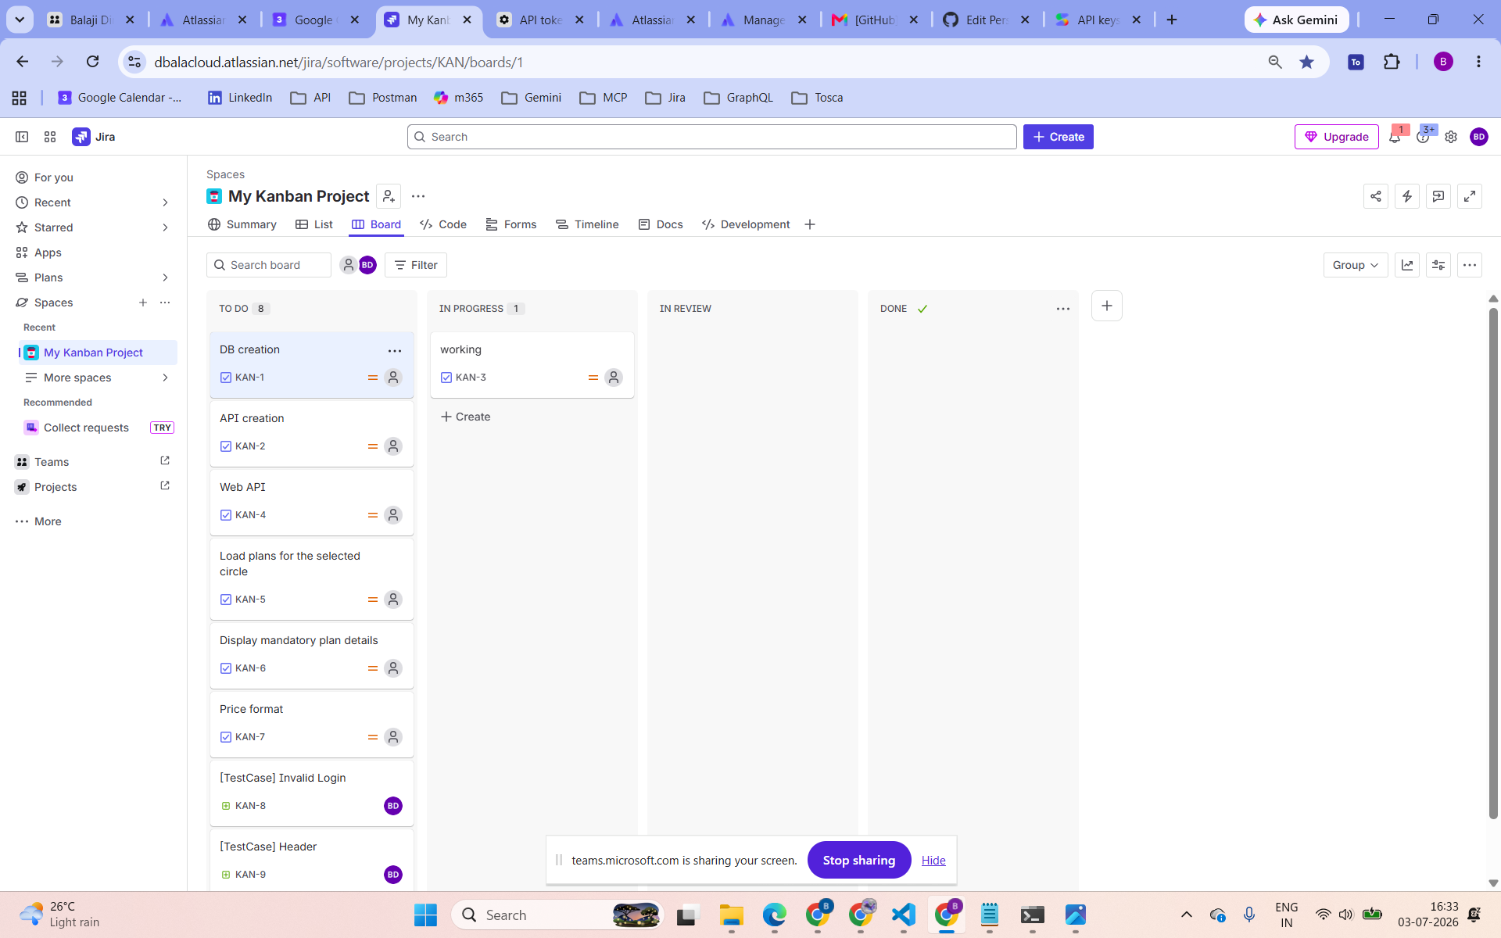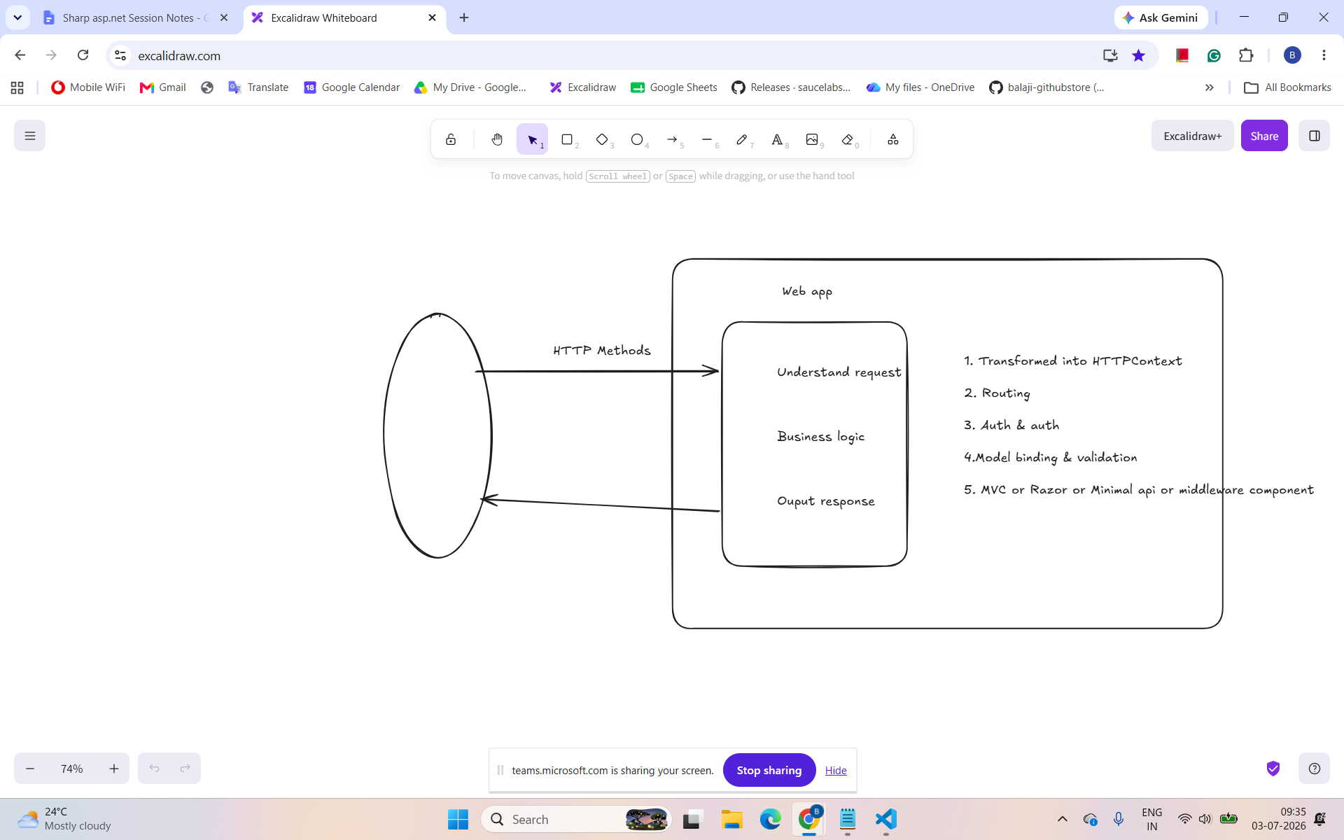

//log files → event,

